HTML AND CSS ASSIGNMENT

NAME-ANMOL BANSAL

COURSE-BTECH CSE AIML 1A

ROLL NO-2K23CSUN01199

**Question: What is the CSS Box Model, and how does it affect the layout of elements on a webpage?**

Ans: The CSS Box Model is a fundamental concept in web design that describes the layout and design of elements on a webpage. It essentially conceptualizes every element on a webpage as a rectangular box, which consists of several parts: content, padding, border, and margin. The CSS Box Model affects the layout of elements on a webpage by influencing the spacing and positioning of elements relative to each other. By adjusting the padding, border, and margin properties, you can control the spacing between elements, create visual separation, and influence the overall structure and design of the webpage.

**Exercise: Provide a simple HTML structure with a few elements and ask the students to apply CSS properties to manipulate the box model, such as margin, padding, and border.**

<!DOCTYPE html>

<html>

<head>

<style>

. box {

width: 100px;

padding: 10px;

margin: 10px;

border: 2px solid red;

} </style>

</head>

<body>

<div class="box">

<h2>Hello</h2>

<p>This is an exercise to manipulate the box model. </p>

</div>

</body>

</html>

**2. Question: Explain the concept of CSS specificity. How is it determined, and why is it important in styling web pages?**

Ans: CSS specificity is a crucial concept in web development that determines which style rules are applied to an element when multiple conflicting CSS rules exist. Specificity is used to decide which style should take precedence when multiple CSS rules target the same element. The specificity of a CSS selector is determined by the combination of the following factors:

a. Inline styles: Inline styles have the highest specificity. Styles applied directly to an element using the style attribute will always take precedence over other CSS rules.

b. ID selectors: ID selectors have a higher specificity compared to class selectors and element selectors. They are denoted by the "#" symbol followed by the ID name.

c. Class selectors, attribute selectors, and pseudo-classes: These have a medium specificity. They are denoted by the "." symbol for classes and can also include attributes and pseudo-classes.

d. Element selectors: These have the lowest specificity and target elements based on their tag names, such as div, p, or span.

By understanding how specificity is calculated, developers can write more efficient and predictable CSS code. They can use specific selectors when necessary and avoid overusing inline styles, which can lead to maintenance issues and make the CSS harder to manage. Understanding specificity is important for creating maintainable, scalable, and well-structured CSS codebases for web pages.

**Exercise: Present a set of HTML elements and CSS rules with varying levels of specificity, and ask students to predict the final styles applied to each element.**

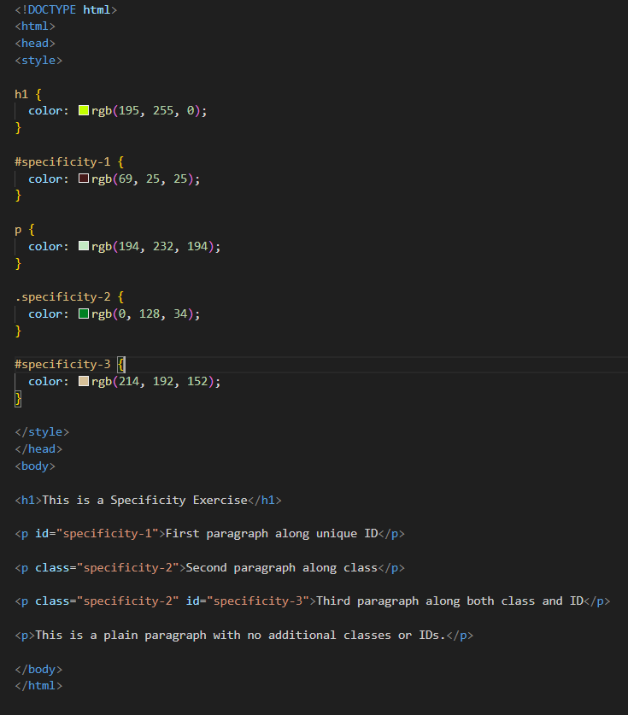

**3. Question: What are CSS Flexbox and CSS Grid? Describe when you would use each layout model, and provide an example of both**.

Ans: CSS Flexbox and CSS Grid are two powerful layout models in CSS that allow developers to create complex and responsive layouts for web pages. Although they both serve similar purposes, they have different use cases and are suited for different layout requirements. 1. CSS Flexbox: CSS Flexbox is designed for one-dimensional layouts, either in a row or a column. It provides a more efficient way to align and distribute space among items in a container, even when their size is unknown or dynamic.

**Exercise: Ask students to create a webpage layout using CSS Flexbox and another using CSS Grid, and compare the differences in the resulting layouts.**

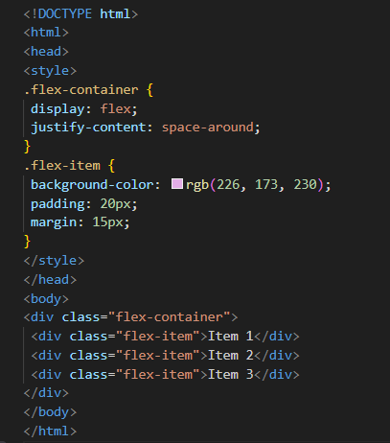

CSS Grid: CSS Grid is a two-dimensional layout system that allows you to create complex grid-based layouts with rows and columns. It provides precise control over both the rows and columns, making it ideal for creating complex and intricate layouts, such as website layouts, image galleries, and any design that requires a structured grid.

CSS Flexbox Layout

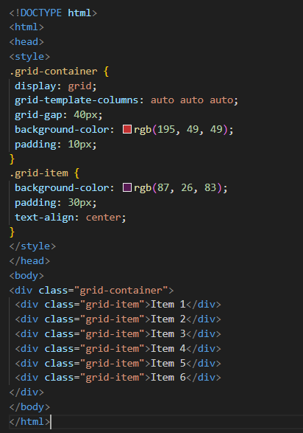

CSS Grid Layout

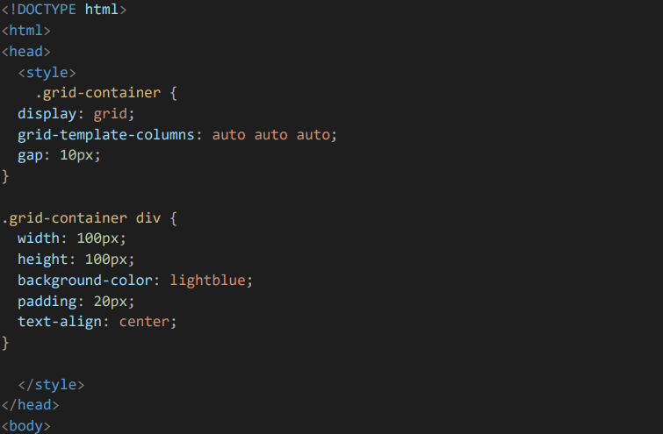

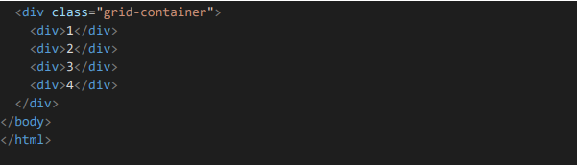

**Question 4: Describe the difference between `position: relative`, `position: absolute`, and `position: fixed` in CSS. When and how would you use each of these position values?**

**Ans:** position: relative:

a. When an element is set to position: relative, it is positioned relative to its normal position within the document flow.

b. This means that the element remains in the flow of the document, and other elements are positioned as if it were still in its normal position.

c. Use position: relative when you want to adjust an element's position relative to its normal position without affecting the layout of other elements.

position: absolute:

d. With position: absolute, the element is positioned relative to its nearest positioned ancestor (an ancestor that is not static) or to the initial containing block if there is no positioned ancestor.

e. The element is removed from the normal document flow, and other elements are positioned as if it were not there.

f. Use position: absolute when you need to position an element precisely in relation to its closest positioned ancestor, often used for creating overlays, dropdowns, and tooltips.

position: fixed:

g. Setting an element to position: fixed positions it relative to the browser window or the viewport. h. The element remains fixed in its position even when the page is scrolled, making it suitable for elements such as navigation bars, headers, or footers that need to remain visible regardless of the scroll position.

i. Use position: fixed when you want an element to remain in the same position relative to the viewport, ensuring it stays visible and accessible while the user scrolls through the content

**Exercise: Provide a webpage with elements that need to be positioned using the different values, and ask students to apply CSS to achieve the desired layout.**

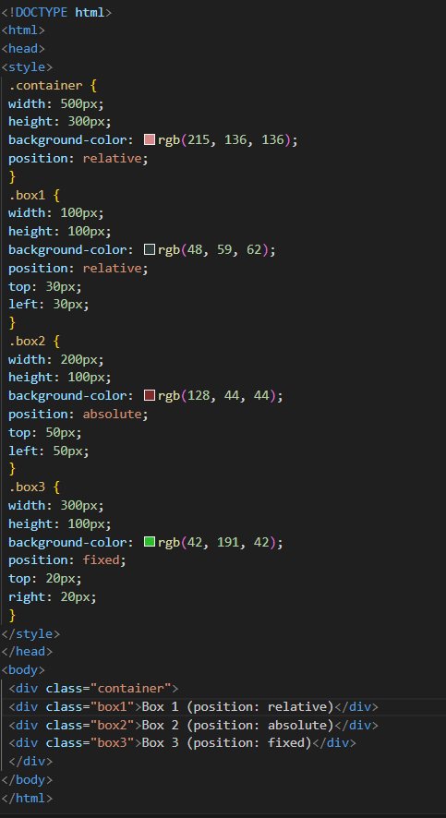

**Ques 5: Explain the concept of CSS pseudo-elements like `::before` and `::after`. Provide an example where these pseudo-elements are used to enhance the design of a webpage.**

Ans: ‘::before’ : This pseudo-element inserts content before the content of the selected element. It is often used to add decorative elements or textual content before an element. ‘::after’ : This pseudo-element inserts content after the content of the selected element. It is commonly used to add decorative elements, icons, or additional styling effects after an element. Exercise: Give students a webpage with specific design requirements and ask them to use pseudo- elements to achieve those enhancements.

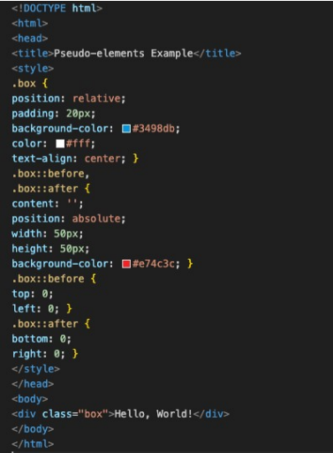

**Ques 6: What is responsive web design, and how can media queries be used to create responsive layouts? Provide an example of a responsive webpage.**

Ans: Responsive web design is an approach to designing and coding websites to provide an optimal viewing and interaction experience across a wide range of devices, from desktop monitors to mobile phones. The goal is to ensure that the website layout and content adapt fluidly to the dimensions of the device's screen.Media queries are a key component of responsive web design. They allow you to apply styles based on various characteristics of the device, such as its width, height, or even the device's orientation.

**Exercise: Provide a basic webpage and ask students to create a responsive design using media queries to adapt the layout for different screen sizes.**

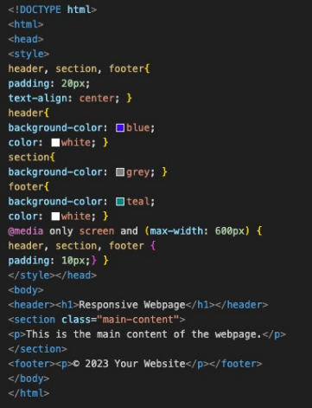

**Ques 7: Discuss the importance of accessibility in web development. Explain ARIA roles and attributes, and provide an example of making a webpage more accessible.**

Ans: Accessibility in web development is crucial as it ensures that websites and web applications can be used by people of all abilities and disabilities. It involves designing and developing websites in a way that makes them perceivable, operable, understandable, and robust for all users, including those with visual, auditory, motor, and cognitive disabilities.

ARIA (Accessible Rich Internet Applications) roles and attributes are part of the Web Content Accessibility Guidelines (WCAG) to enhance the accessibility of dynamic content and advanced user interface controls.

Roles: ARIA introduces roles that can be applied to elements to define their intended purpose. For example, role="button" can be added to a

to indicate that it functions as a button.

Attributes: ARIA attributes provide additional information about the state or property of an element. For instance, aria-hidden="true" can be used to hide an element from assistive technologies, and aria-labelledby can be used to associate an element with another element that serves as its label.

**Exercise: Offer a webpage with accessibility issues, and ask students to improve its accessibility by adding ARIA roles and attributes.**

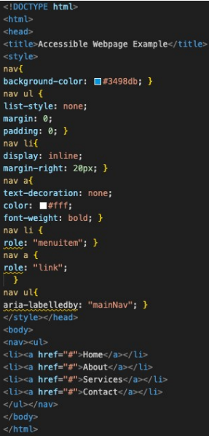

**Ques 8: What is the purpose of the `` declaration in HTML, and how does it affect the rendering of a webpage in different browsers?**

Ans: The declaration in HTML (Hypertext Markup Language) is used to specify the version of HTML or XHTML that a web document is using. It serves as an instruction to web browsers and other software about how to interpret the markup of the document. The purpose of the declaration is to ensure that the web document is displayed correctly and consistently across different web browsers. Different web browsers have their own rendering engines, which interpret HTML and CSS to display web content. The presence of a correct and valid declaration ensures that the browser renders the webpage in standardscompliant mode, following the specified rules and standards for the declared version of HTML or XHTML. This helps maintain consistency and predictability in how the webpage is displayed across different browsers and devices.

**Exercise: Ask students to create a simple HTML document and experiment with different `` declarations to observe how they affect the rendering in various browsers**.

